Three Rivers District 2026 Calendar
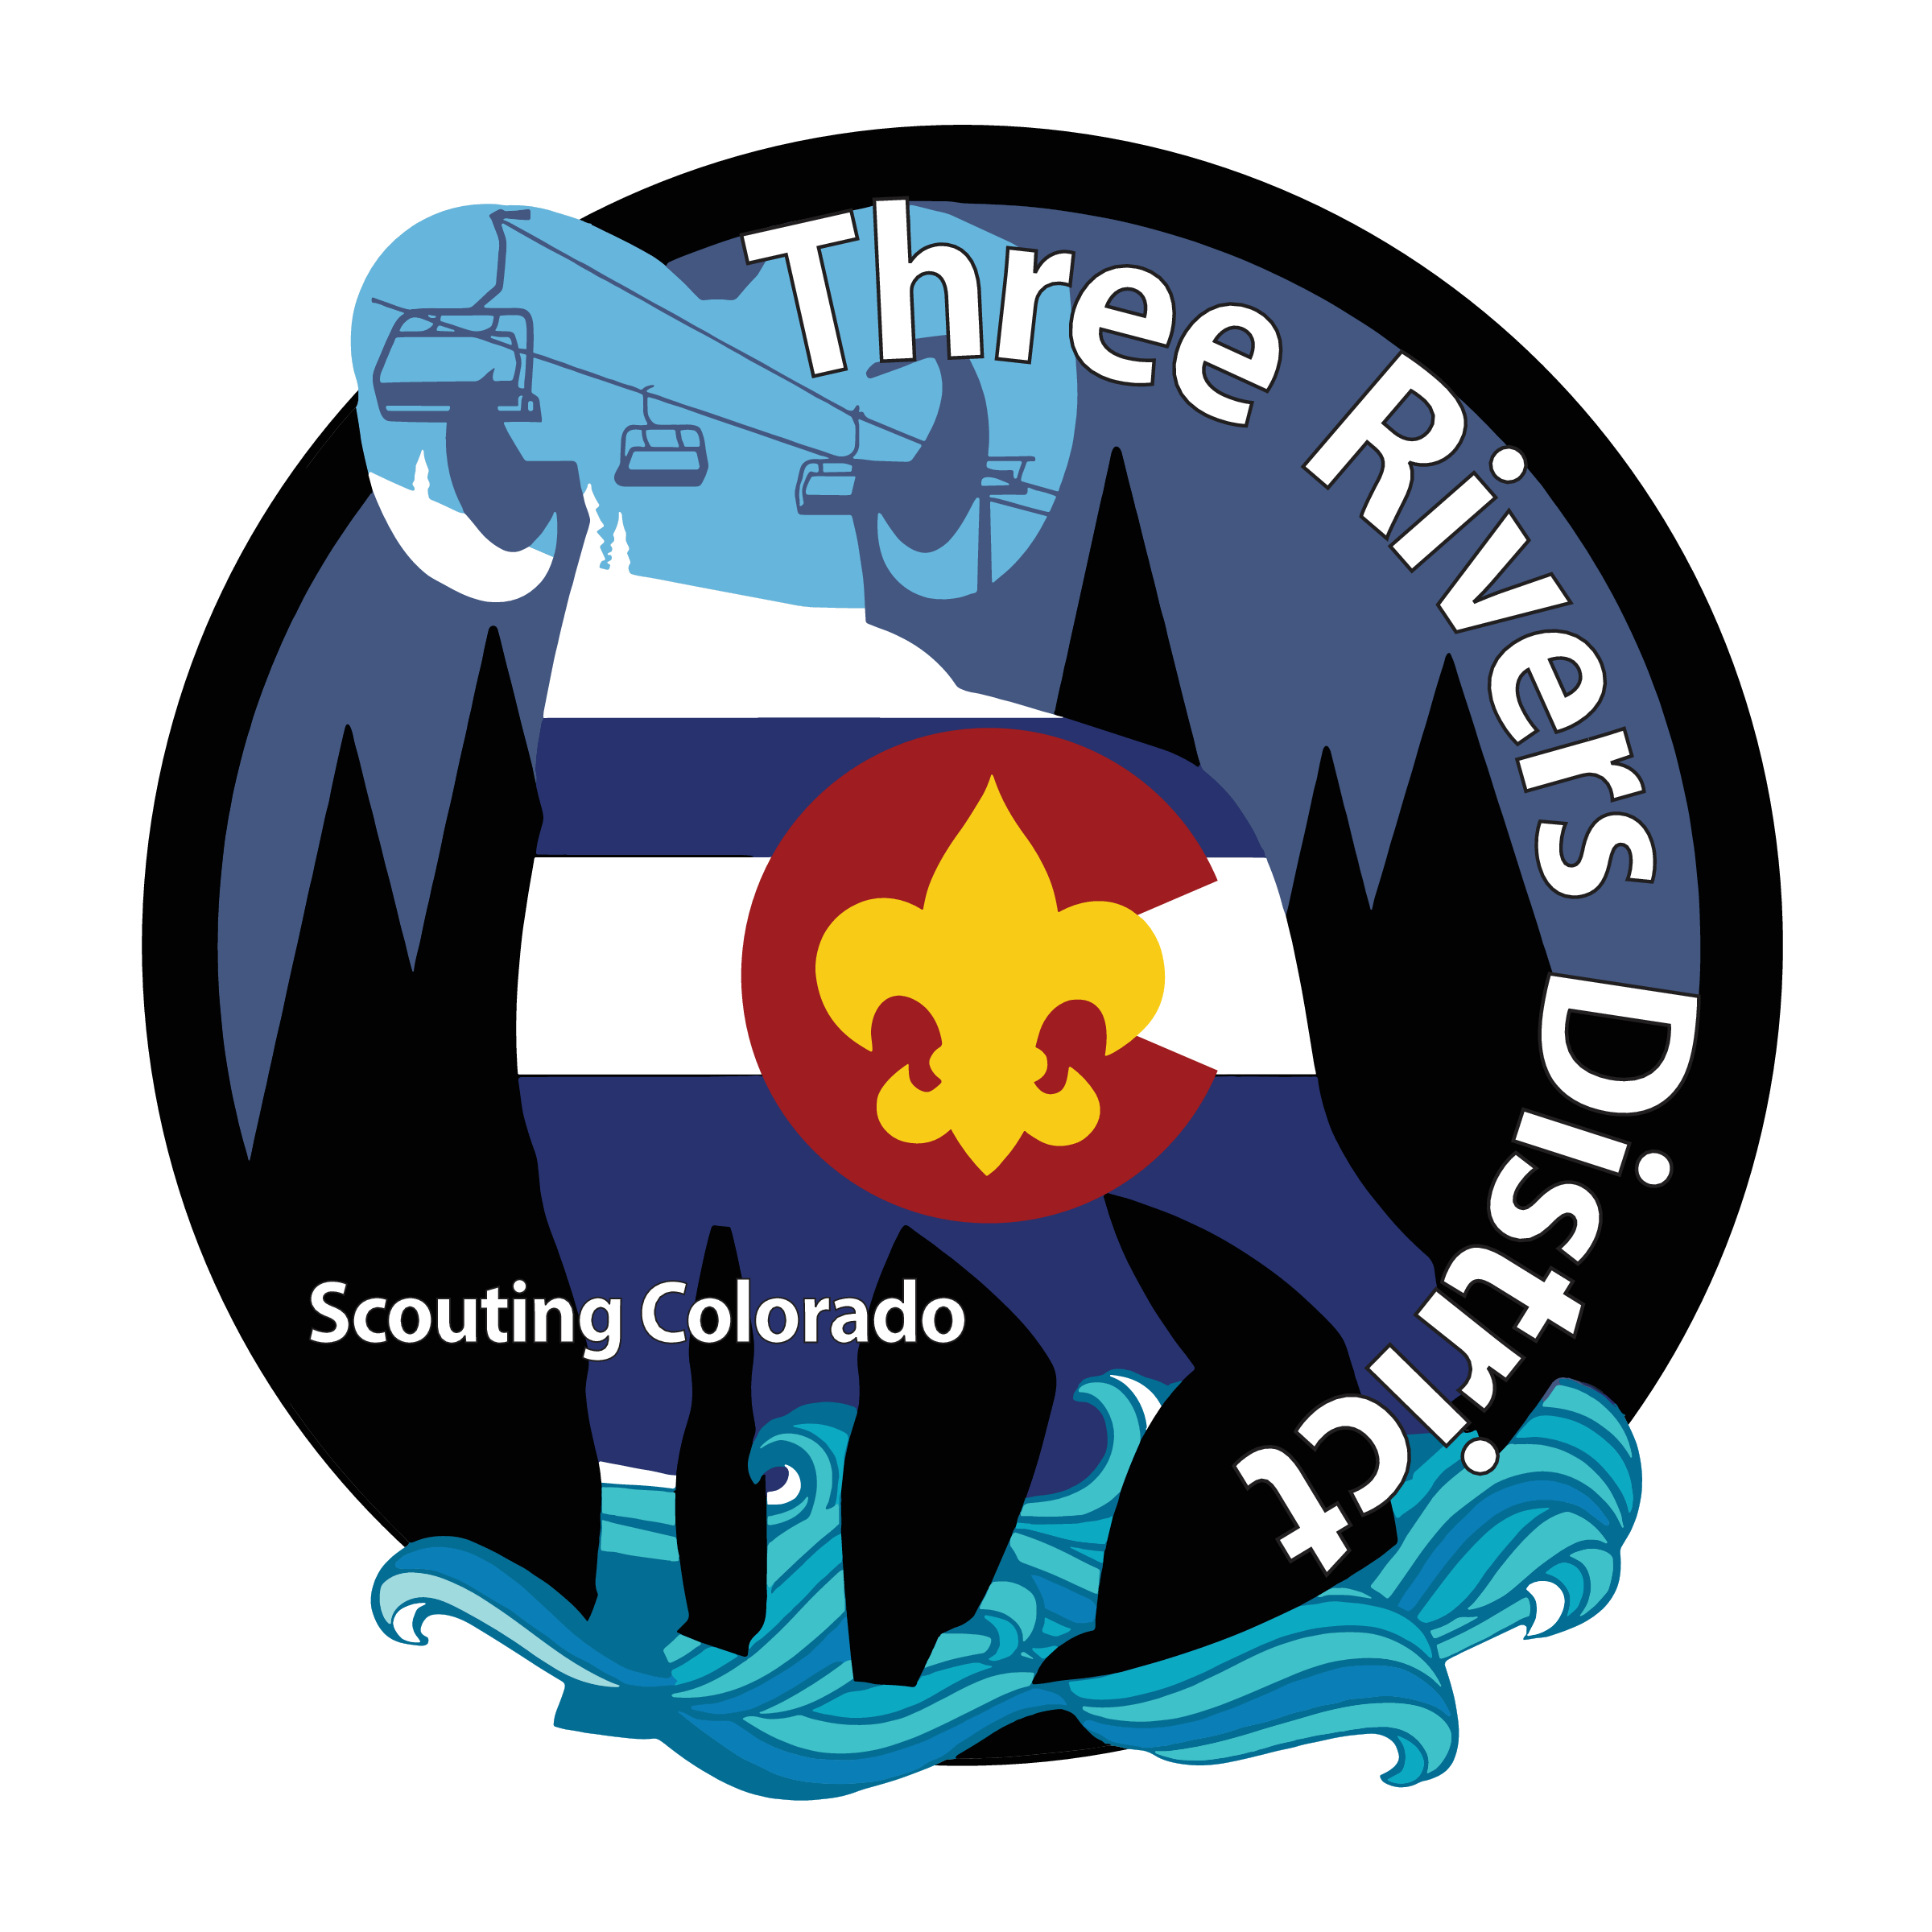
January
- Three Rivers Roundtable January 8th, 2026 @ ZOOM
- District Annual Business Meeting January 28th @ ZOOM
February
- Three Rivers Roundtable February 5th, 2026 @ ZOOM
- Three Rivers Committee Meeting February 25th, 2026 @ ZOOM
March
- Three Rivers Roundtable March 5th, 2026 @ ZOOM
- Three Rivers Committee Meeting March 25th, 2026 @ ZOOM
- District Klondike March 13th – 15th, 2026
April
- Three Rivers Roundtable April 2nd, 2026 @ ZOOM
- Three Rivers Committee Meeting April 22nd, 2026 @ ZOOM
May
- Three Rivers Roundtable May 7th, 2026 @ ZOOM
- Three Rivers Committee Meeting May 27th, 2026 @ ZOOM
- IOLS Training May 2nd – 3rd at Wolford Mountain Reservoir in Kremmling, CO
June
- Three Rivers Roundtable June 4th, 2026 @ ZOOM
- No Three Rivers Committee Meeting scheduled
- BALOO Training June 5th – 6th at Jolley Ranch, New Castle, CO
- Cub Scout Day Camp June 6th at Jolley Ranch, New Castle, CO
July
- No Three Rivers Roundtable scheduled
- No Three Rivers Committee Meeting scheduled
August
- Three Rivers Roundtable August 6th, 2026 @ ZOOM
- Three Rivers Committee Meeting August 26th, 2026 @ ZOOM
September
- No Three Rivers Roundtable Meeting scheduled
- Three Rivers Committee Meeting September 23rd, 2026 @ ZOOM
- District Awards Banquet September 5th @ TBD
- Fall Camporee September 18th-20th @ TBD
October
- Three Rivers Roundtable October 7th, 2026 @ ZOOM
- Three Rivers Committee Meeting October 27th, 2026 @ ZOOM
November
- Three Rivers Roundtable November 5th, 2026 @ ZOOM
- Three Rivers Committee Meeting November 18th, 2026 @ ZOOM
- Merit Badge University November 14th @ TBD
December
- Three Rivers Roundtable December 3rd, 2026 @ ZOOM
- Three Rivers Committee Meeting December 23rd, 2026 @ ZOOM

